# Rover Challenge Fund - Application Form

*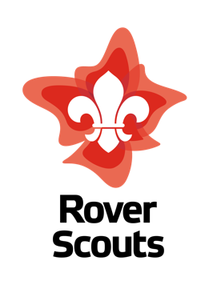The purpose of the Rover Challenge Fund is to encourage Rover Units to further develop their program by challenging themselves and pushing their boundaries. Rover Challenge Fund grants are available to groups of registered Rover Scouts who are planning community projects or wishing to undertake specific Outdoor Adventure Skills courses. Examples of these initiatives are: Wilderness First Aid Courses, Adventurous Activity Instructor Courses, community projects*. *The grant is not designed to fund entire projects but is there to provide the initial funding for start-up costs. The activity group will need to provide both a final report and invoices for the activity that a grant has been provided for.*

*Please send submissions or questions to the NRC Vice Chair at* [*nrcvicechair@scouts.com.au*](mailto:nrcvicechair@scouts.com.au)

|  |  |  |
| --- | --- | --- |
| **Applicant Details** | | |
| **Name** |  | |
| **Group/Crew/Unit** |  | |
| **Membership Number** |  | |
| **Contact Details** | Phone Number: | Email: |
| **Selection Criteria** | | |
| **Outline of the project.** |  | |
| **How will this project impact on the Rovers and/or Units participating?** |  | |
| **What is the estimated total cost for this project, and how much is your group applying for ($1000 limit)?** |  | |
| **How will your group pay for the rest of the project?** |  | |
| **What is the timeline for this project?** |  | |